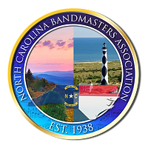
Hall of Fame Nomination
Letter of Support

Date______________________

To: The NCBA Hall of Fame Committee

Re: (Name of Candidate)_____________________________________________

is among the most outstanding NC Band Directors and has my full support to advance through the nomination process for the NCBA Hall of Fame. I have observed them demonstrate ALL requirements of a NCBA Hall of Fame nomination including:
- Served as an active band director in music education in the North Carolina Public or private schools for a period of not less than ten years
- Demonstrated excellence in teaching
- Consistent maintenance of a well-balanced band program
- Contributions to the improvement of music education and the betterment of the profession derived from leadership positions at district, state and national levels
- Strong record of active participation in various NCBA activities
- Fulfillment of the highest ethical ideals and professional integrity during the time of service
- Fully retired from service for a minimum of 5 years (but can be currently working).

I respectfully recommend that this candidate be nominated for the NCBA Hall of Fame.

Sincerely,

______________________________________ (Name of Hall of Fame Member)

______________________________________ (Signature)

______________________________________ (Contact Information)

